Incident Number (20060228-01)

Description

The time in Sendero is not updating – the field annotated in red on the screen below.
This field is updated every 10 minutes based on a time posted in the Sendero database by the Penson Service.

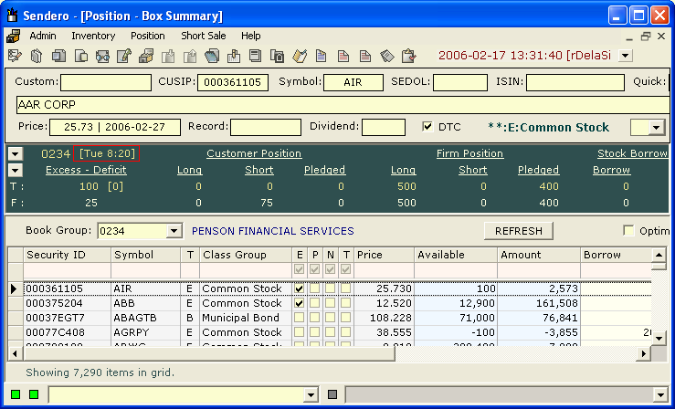

Symptoms

- Check the Penson Service to ensure that it is running
- Check the Penson Service application log for error messages such as database timeouts, etc.
- Check the Event Log on WWPEN002 for Penson Service Errors

How to Correct

Ensure the Penson Service is running. If database timeouts are occurring, determine if there is anything slowing the Apollo/History Database Server or the Sendero database. This problem can be caused by the Nightly Batch process running late.

Action Taken to Prevent Future Occurrences

None. Other than the Penson Service being shut down, this problem can be caused by production and other issues affecting the performance of the Apollo/History server.

